**CONTACT US PAGE**

1. We are going to use [Xampp](https://www.apachefriends.org/) to test this project of ours
2. First of all, After installing Xampp, we start the Apache Web Server and MySQL Database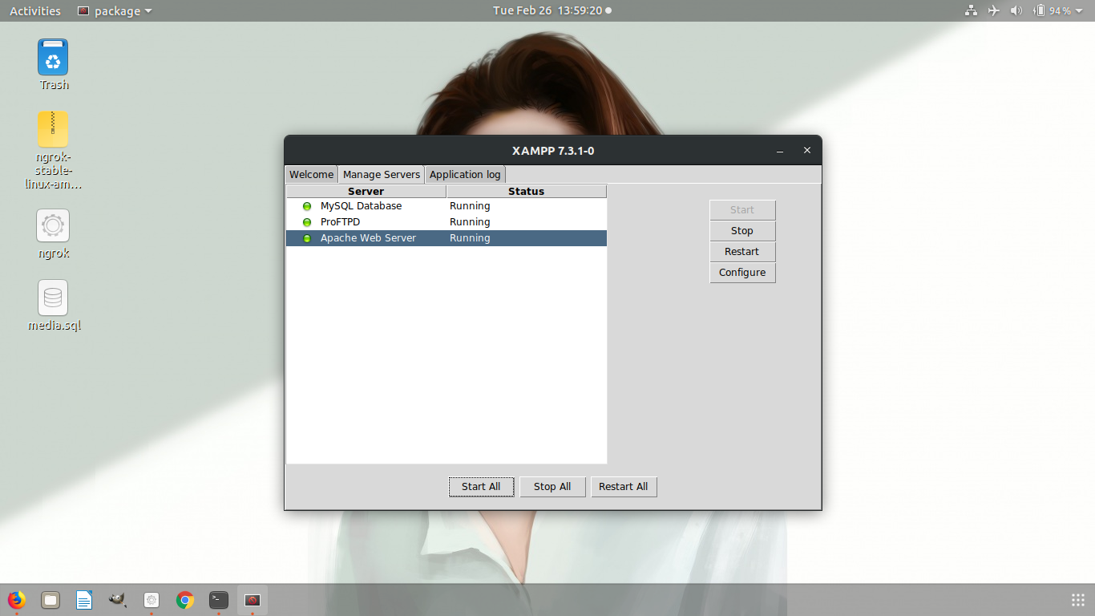
3. Then open up your browser and go to *“localhost/phpmyadmin”* 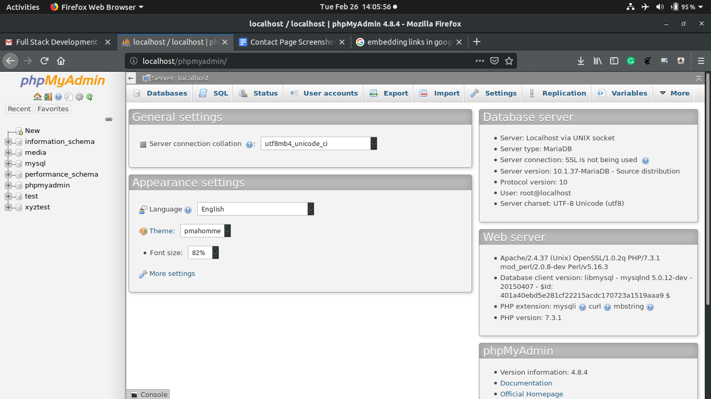
4. First we create a database named “*formData*”. After creating it we navigate into it through the side panel
5. Then we will go to the “*Import*” tab and import the “*formData.sql*” file,which I have attached along with the webpage folder. After that click the “*go*” button below.
6. Next step is to take the folder “*contactpage*” which is also attached in this mail, and paste it into the “*htdocs*” folder of your xampp installation folder so it should look something like this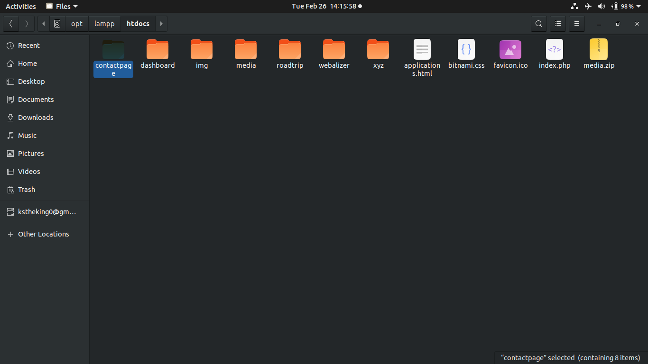
7. Next we go to the browser to the address “*localhost/contactpage*” and it will look like this 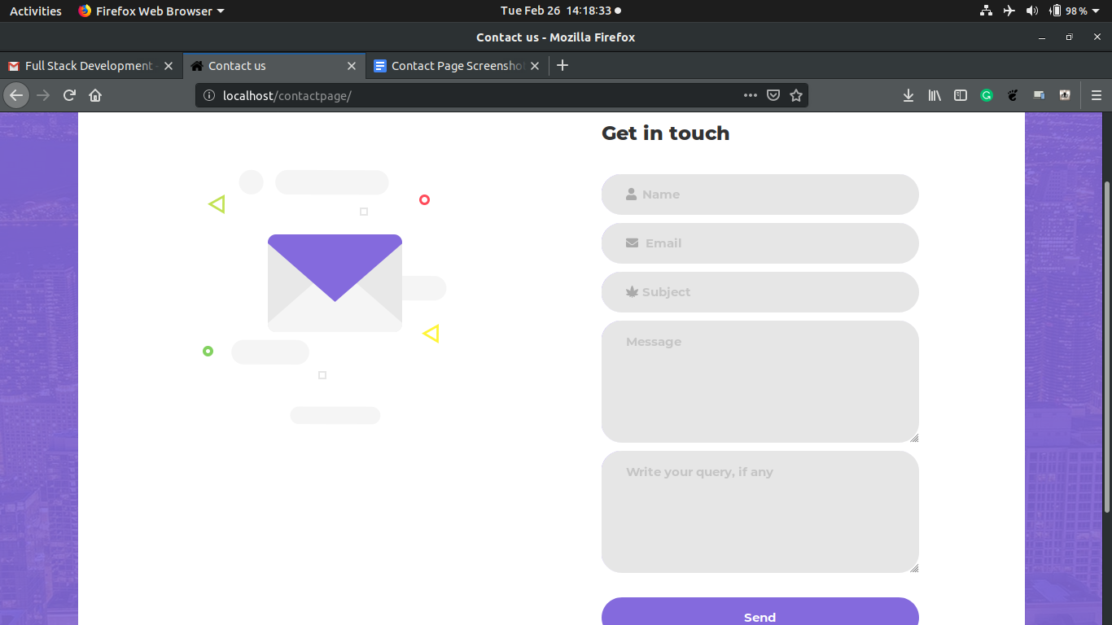
8. In case you fill up something wrongly, appropriate error messages are displayed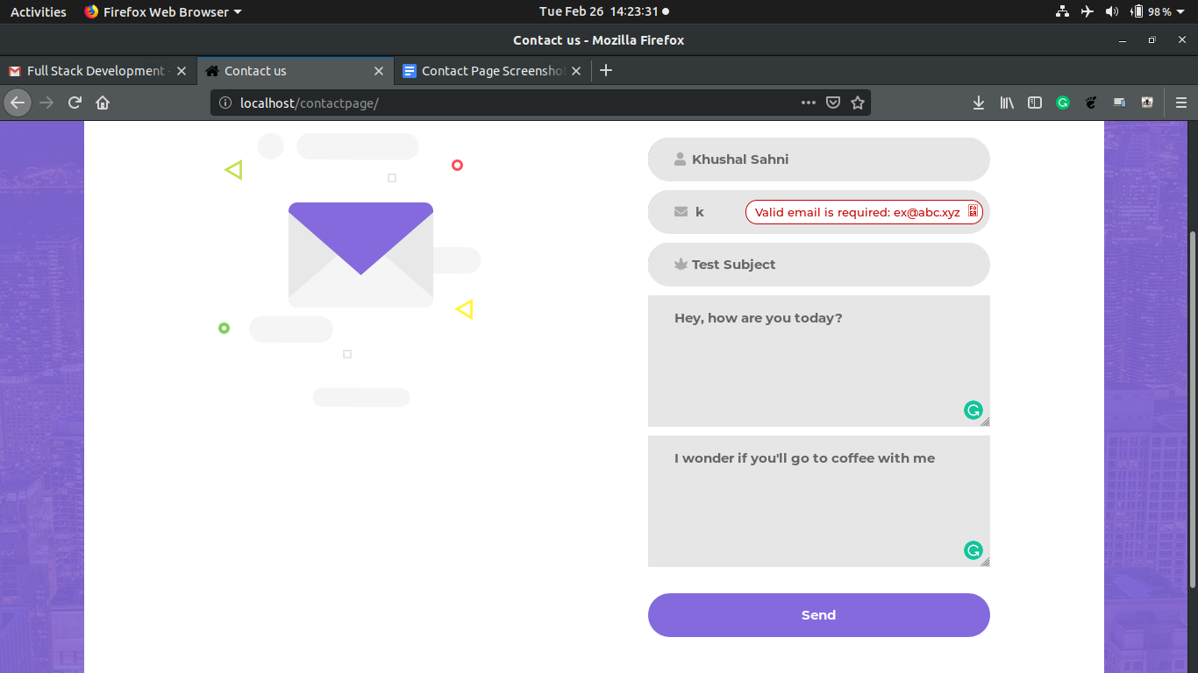
9. Now after filling up all the details properly, when you click the submit button, this page gets displayed 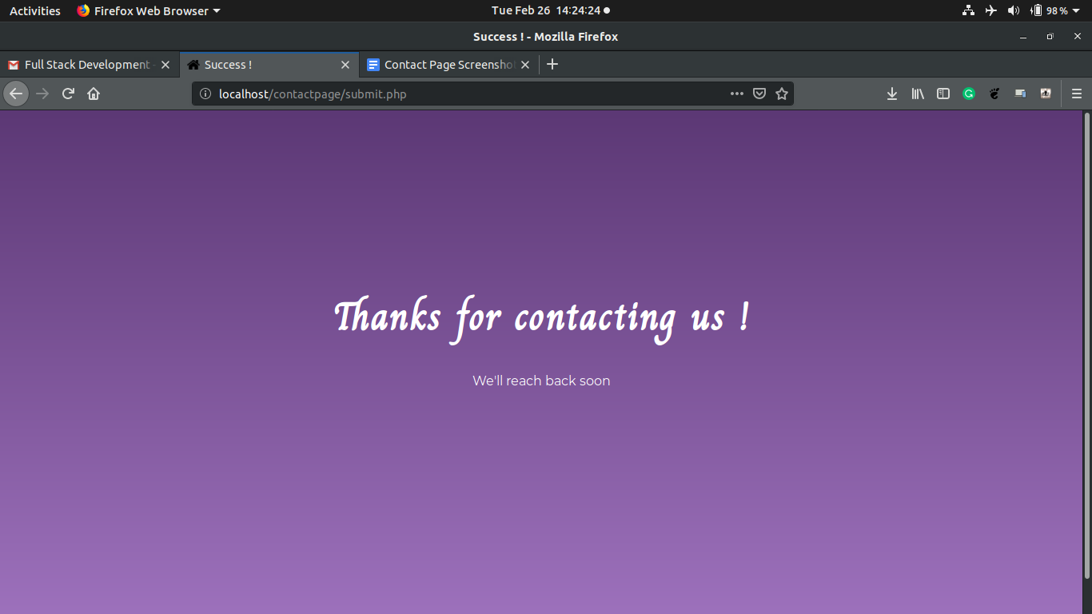
10. Now, to check the details of all form submissions, you can navigate to “*localhost/contactpage/details.php*”, which will look something like this 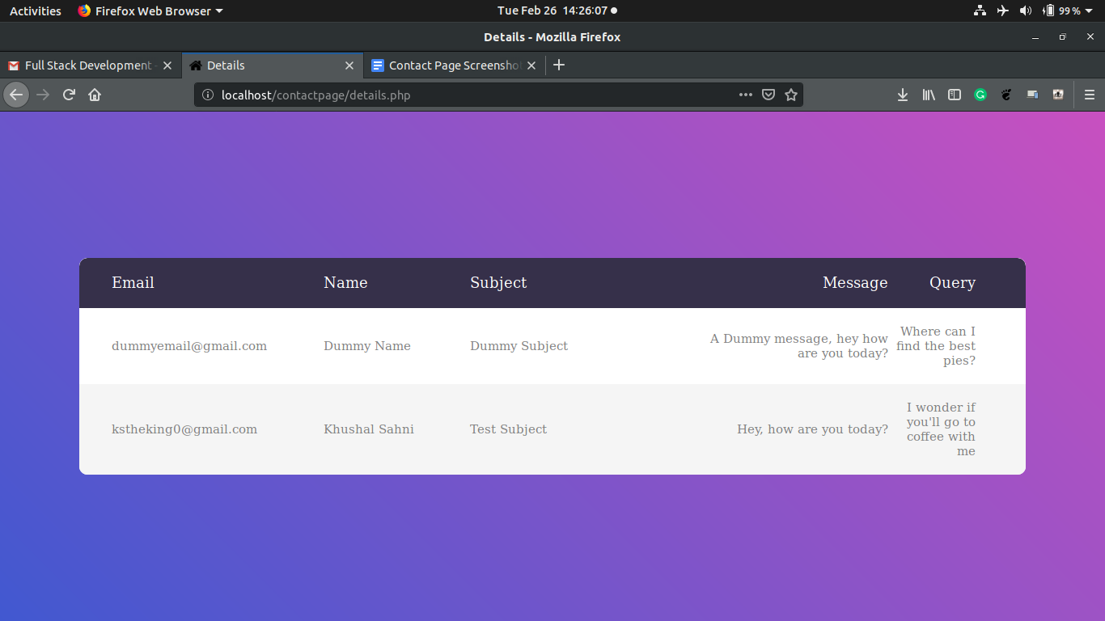

**THANKS !**